**LAB 3 _ GROUP 3**

1. **TEST**
2. **Add product**

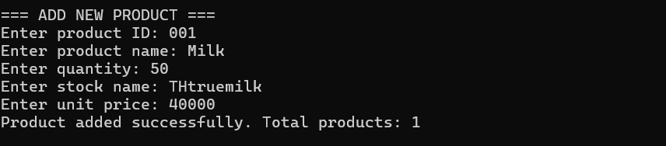

1. **Delete product**

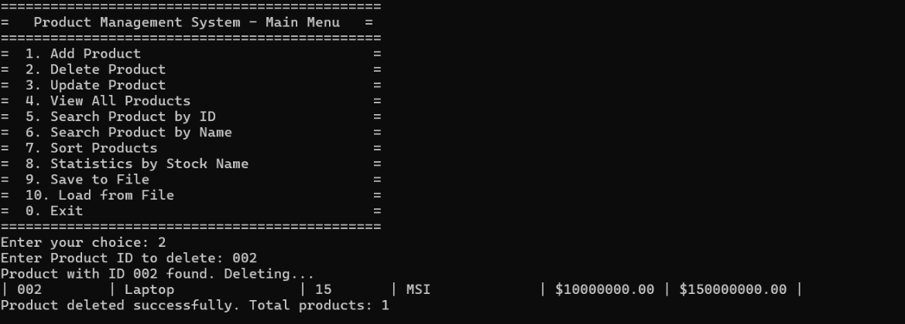

1. **Update product**

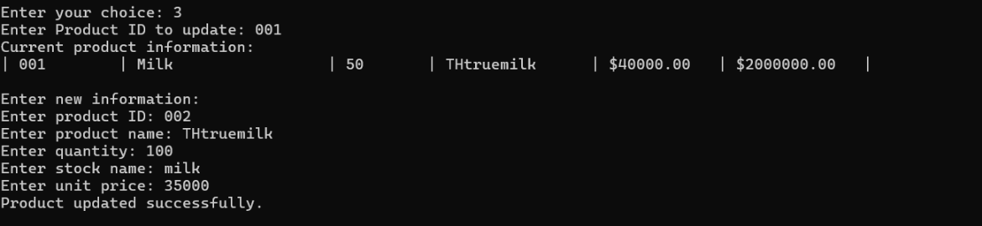

1. **View All product**

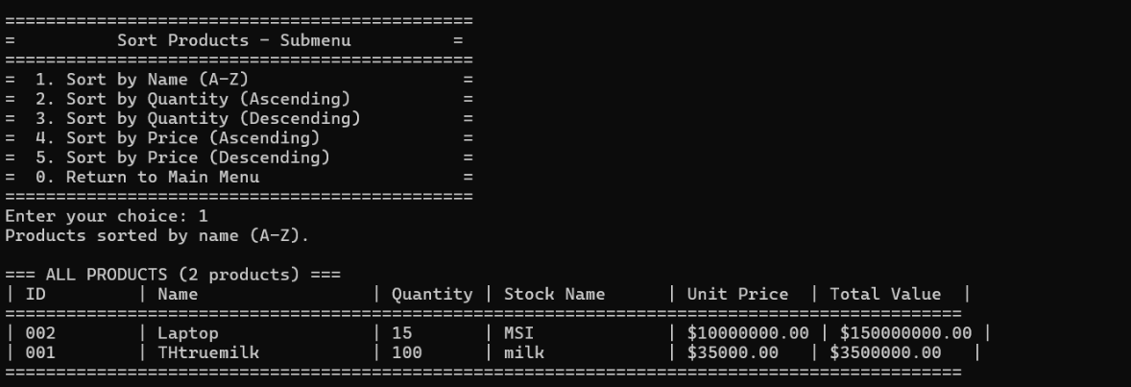

1. **Search product by ID**

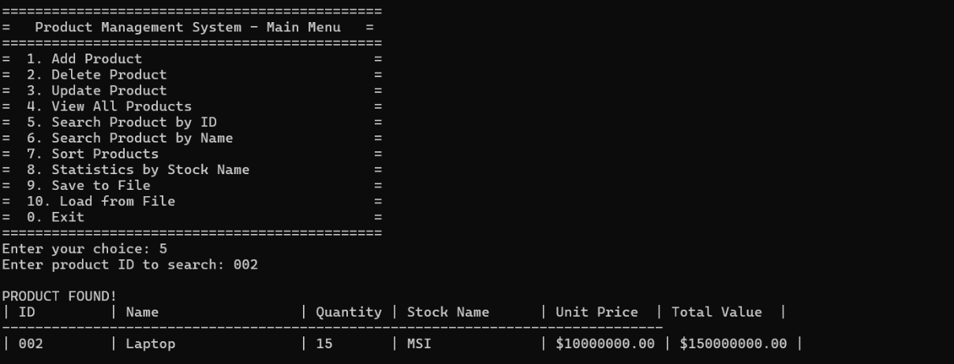

1. **Search by Name**

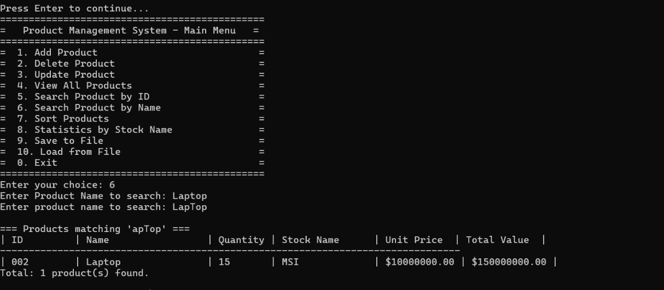

1. **Sort**

**7.1 sort by name**

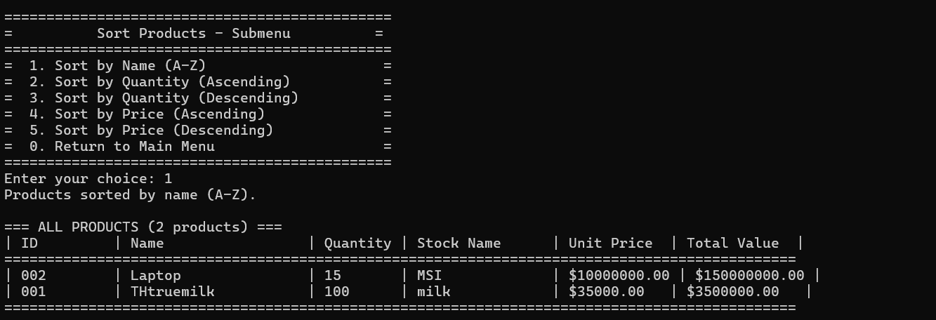

**7.2 sort by Quantity**

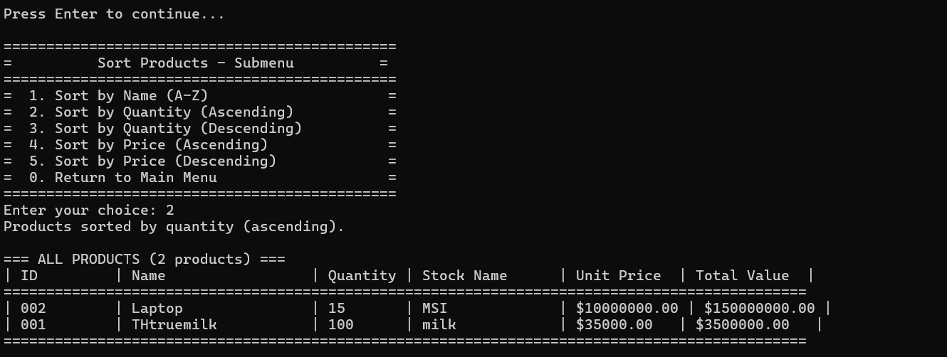

**7.3 sort by price**

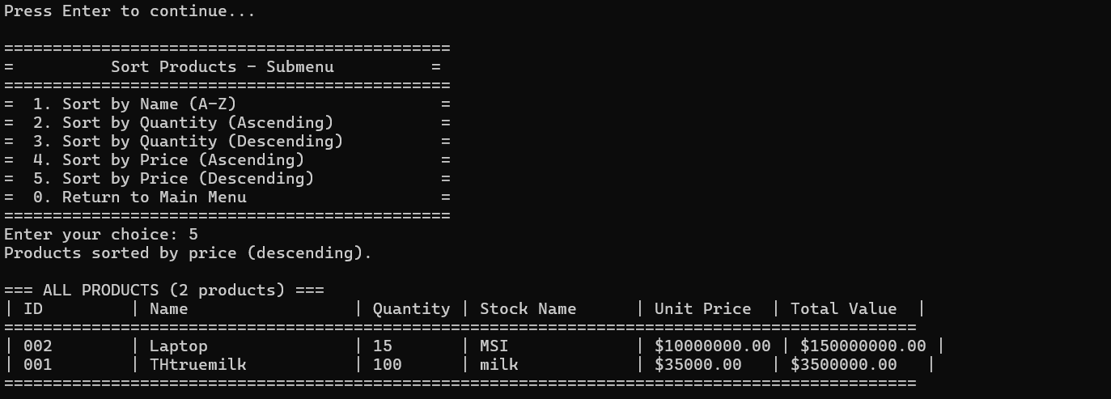

1. **Statistic by Stock Name**

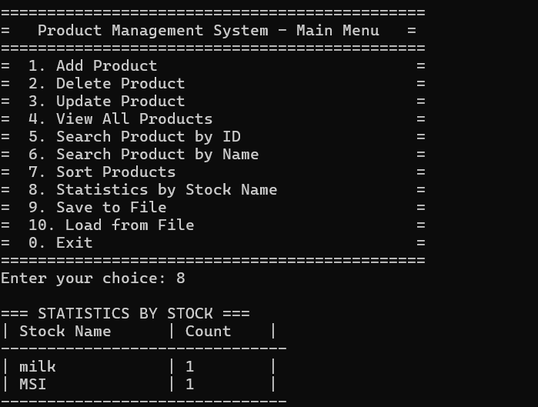

1. **Exit**

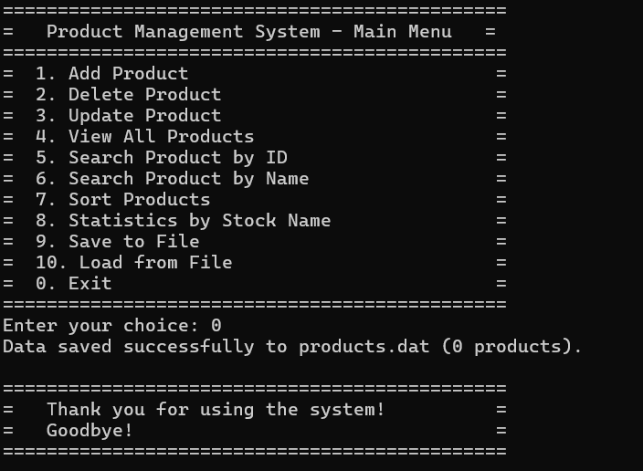

1. **Debug**

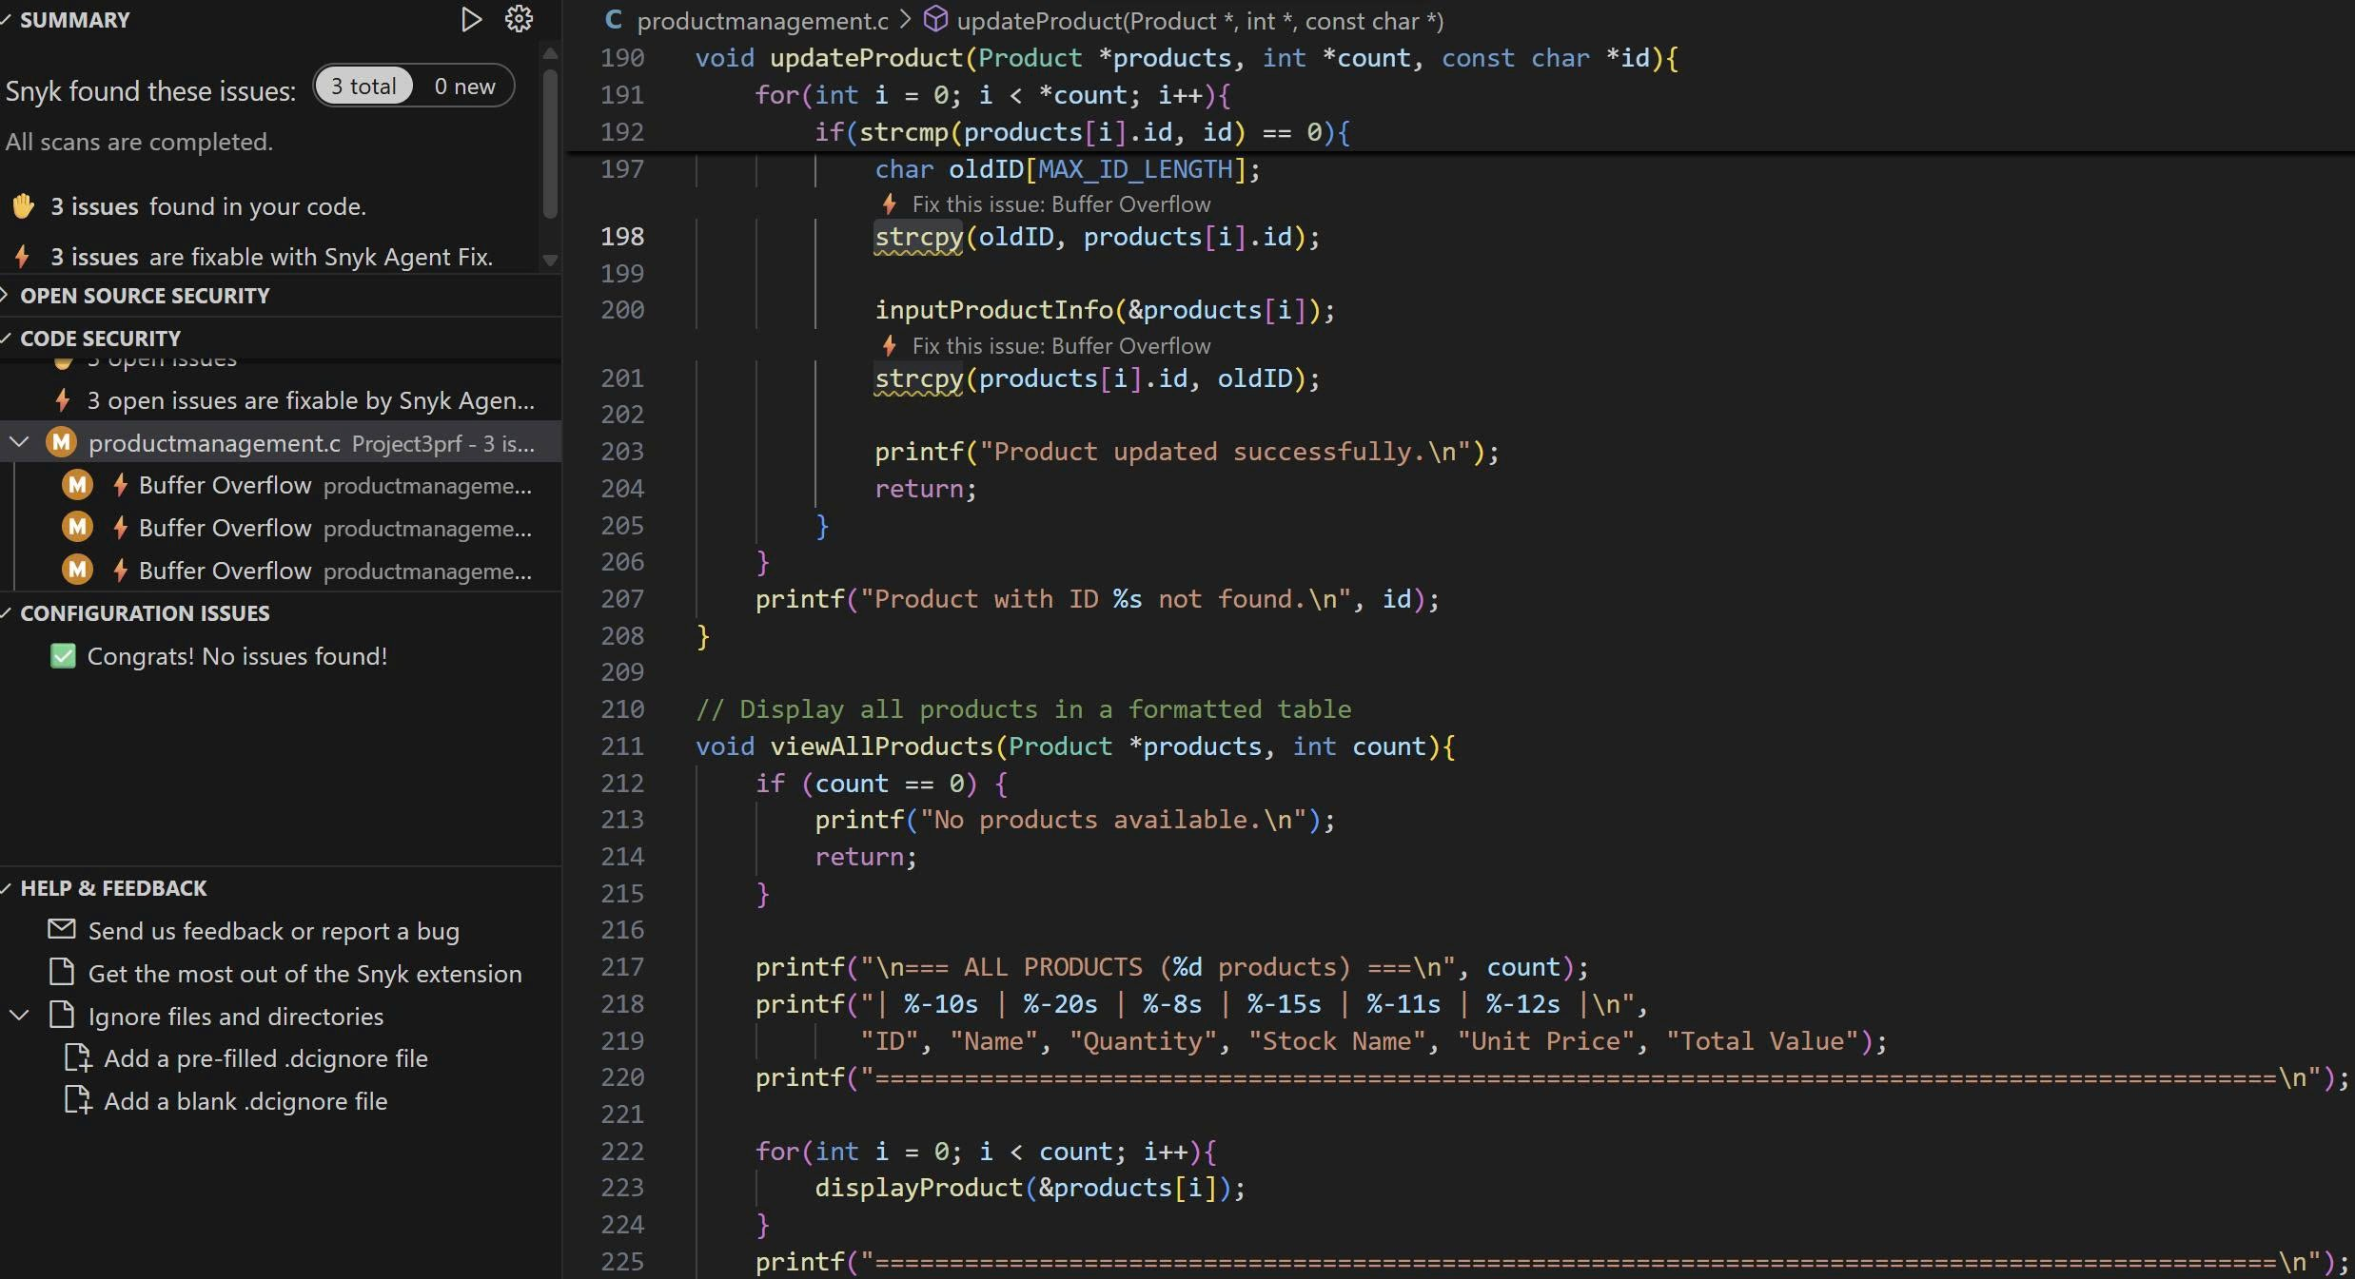

1. **CODE**
2. **Declaration**

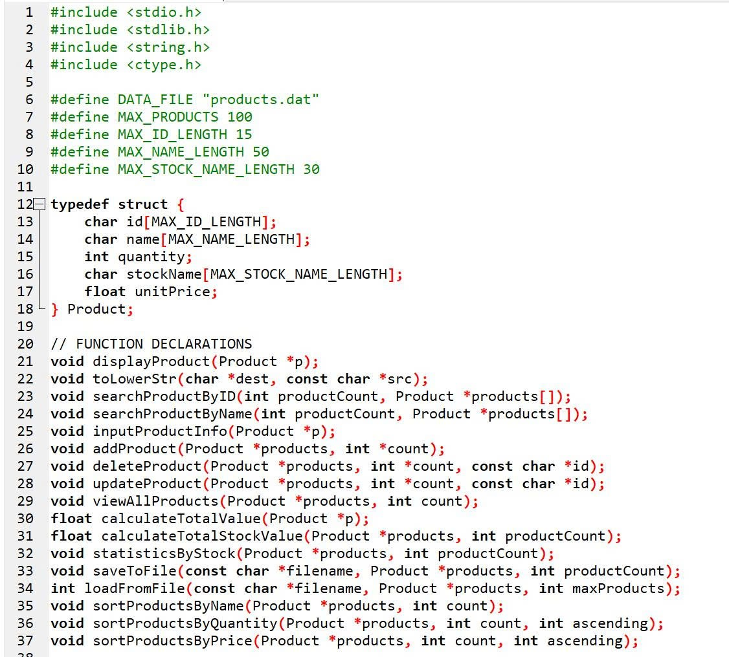

1. **Main function**

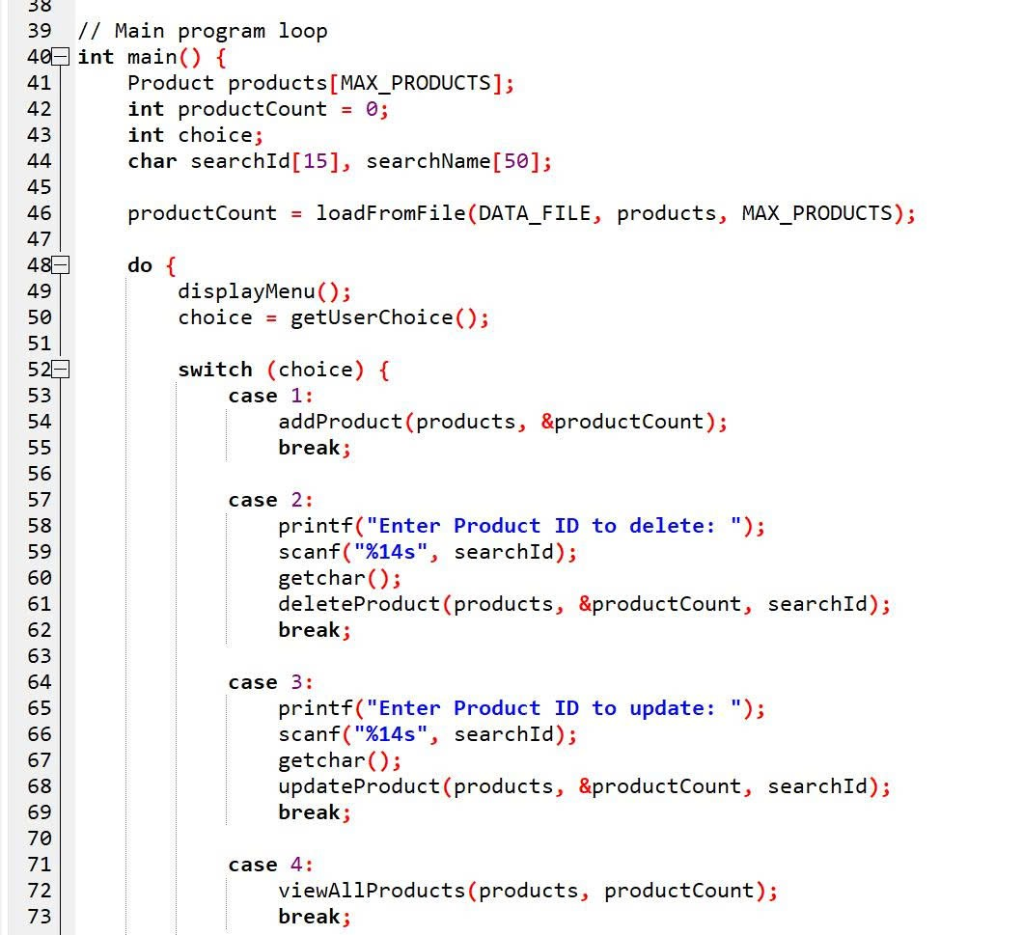

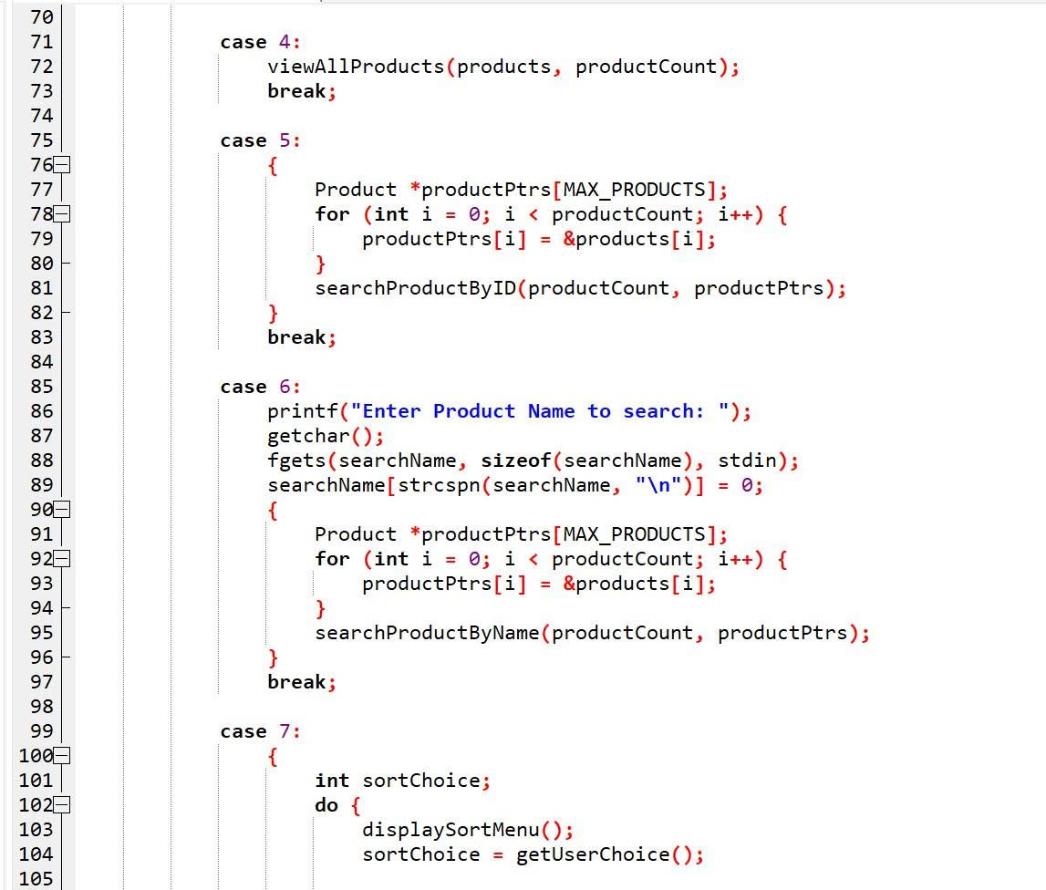

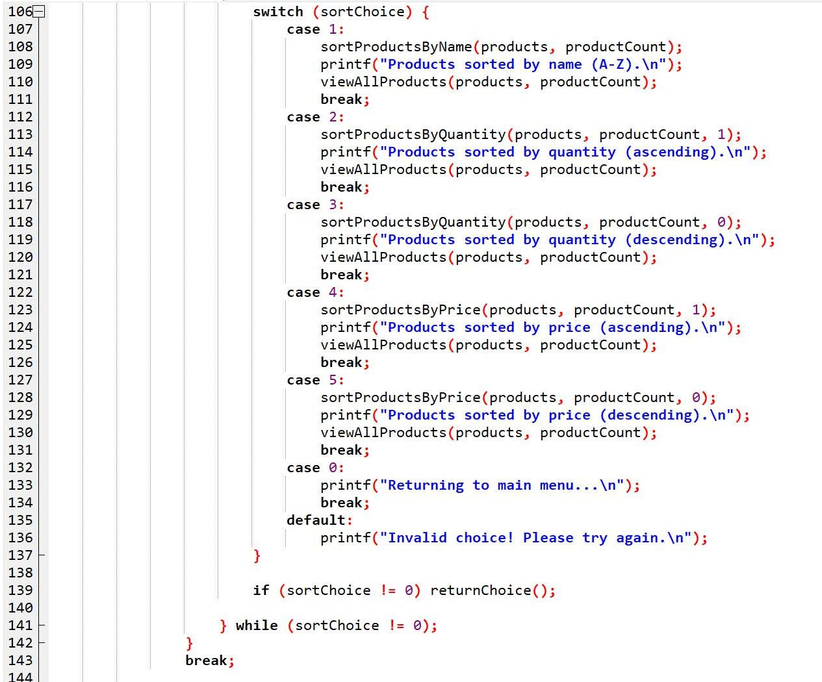

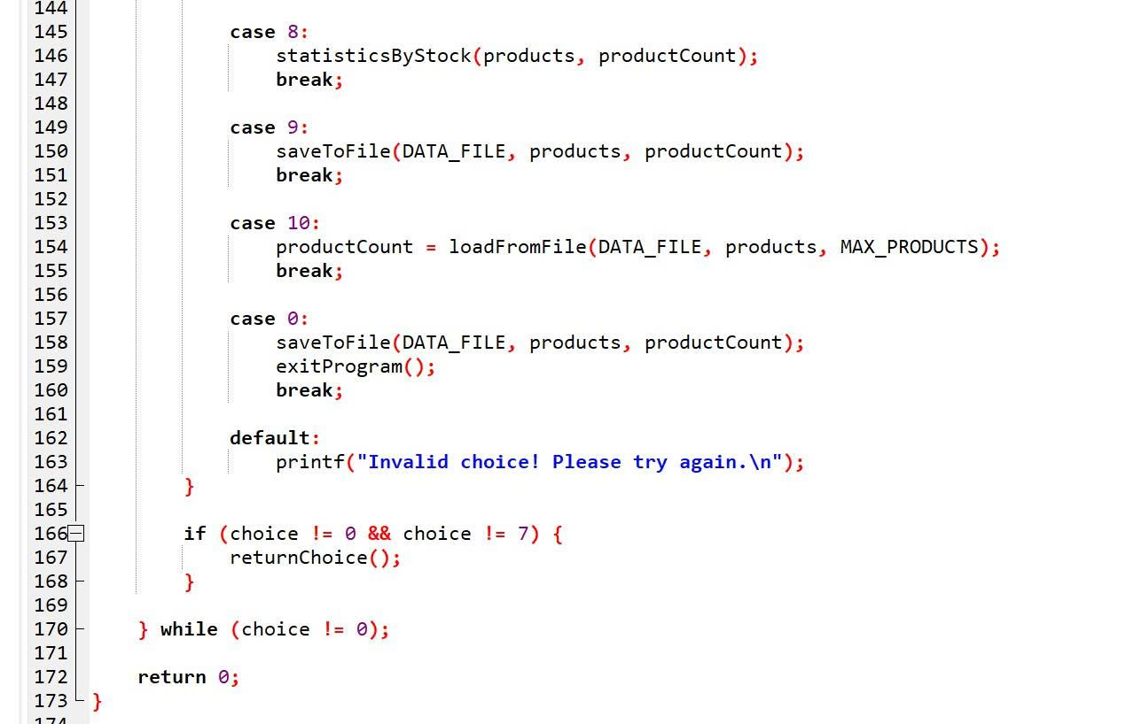

1. **Display product**

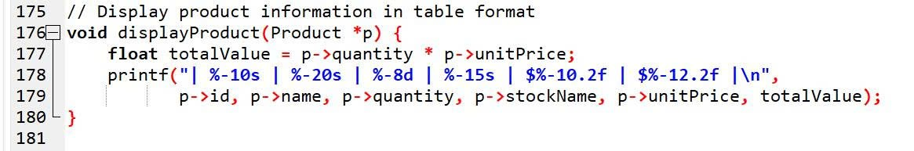

1. **To LowerStr**

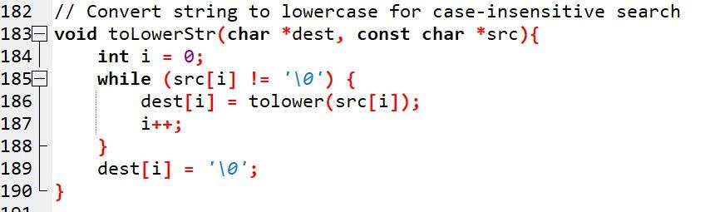

1. **Search by ID**

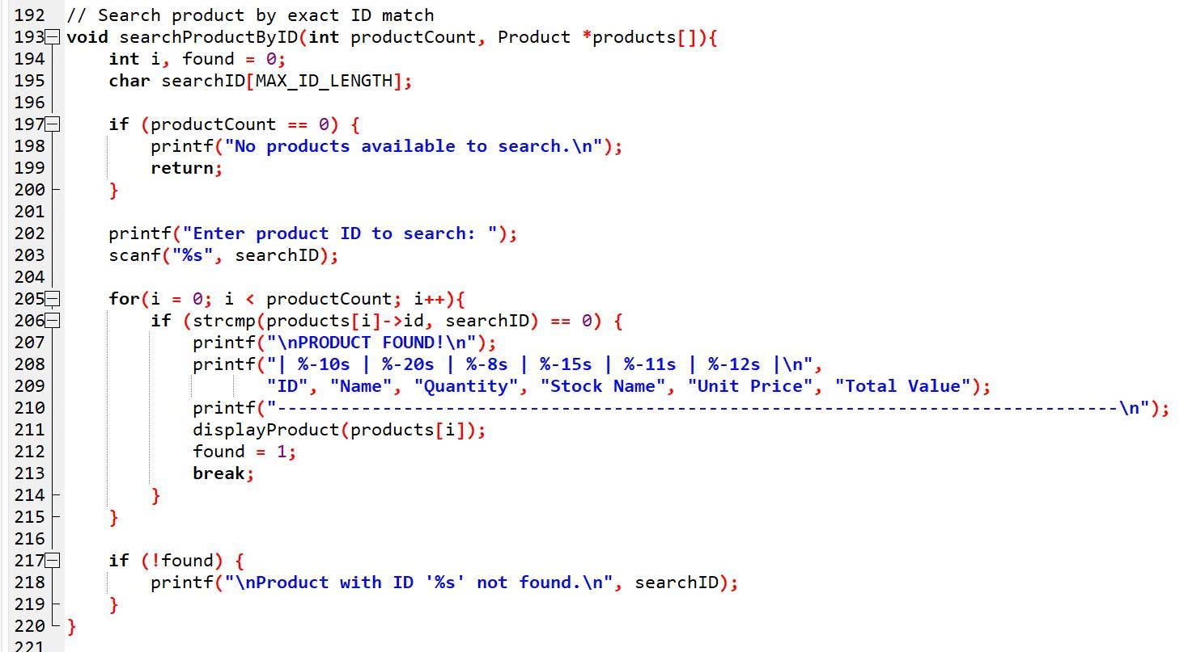

1. **Search by Name**

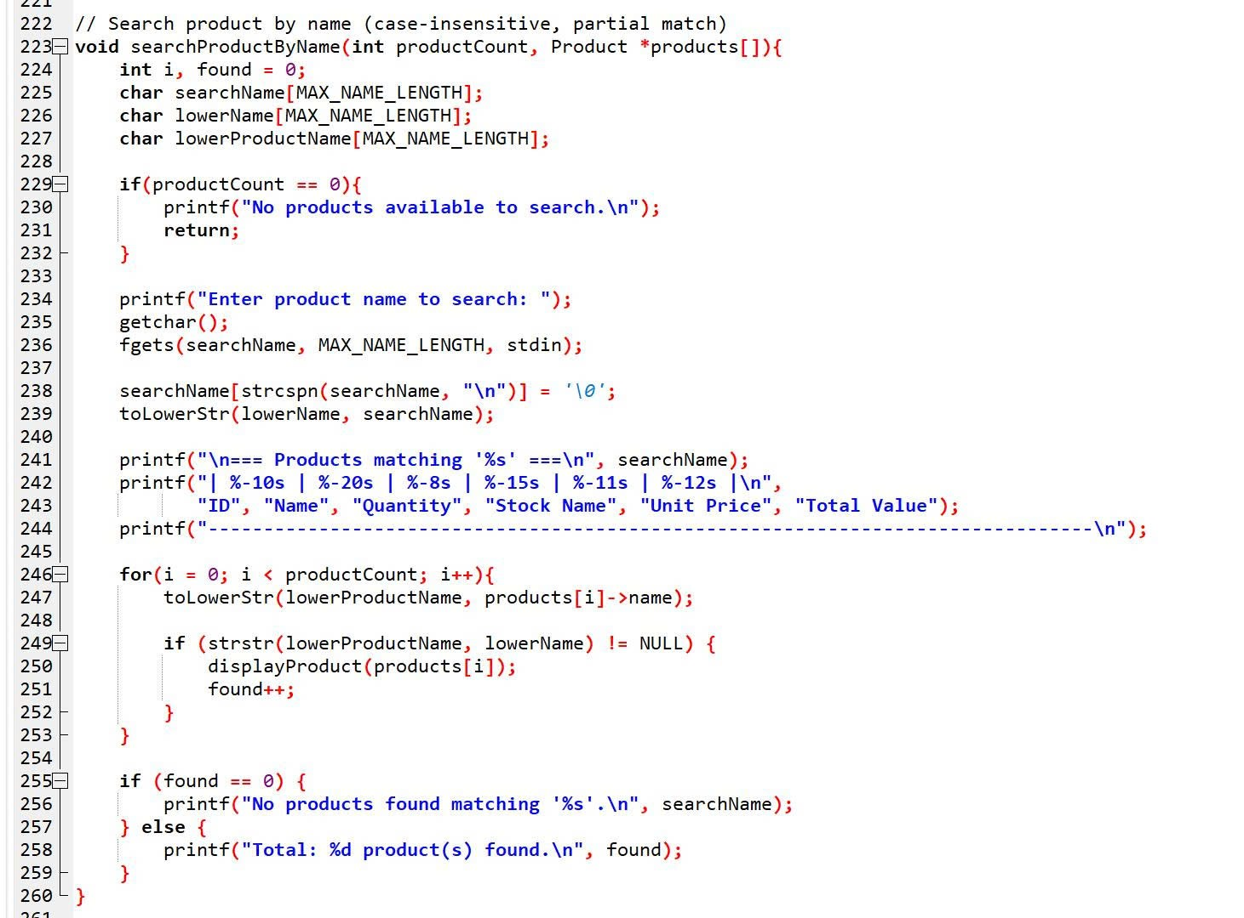

1. **Inputinfo**

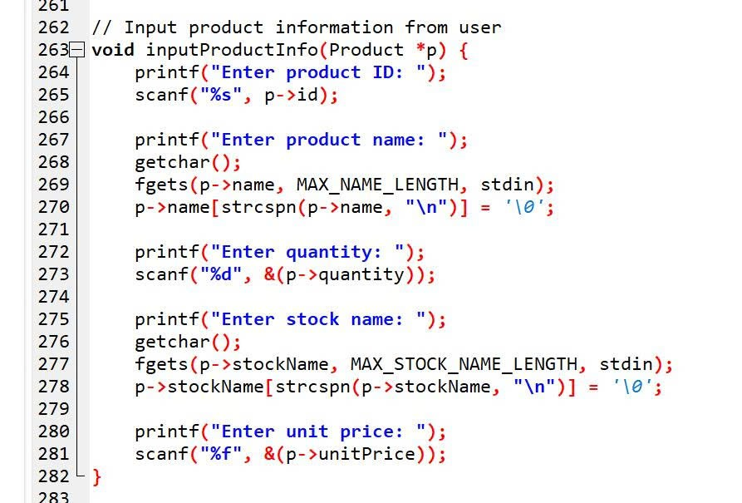

1. **Add product**

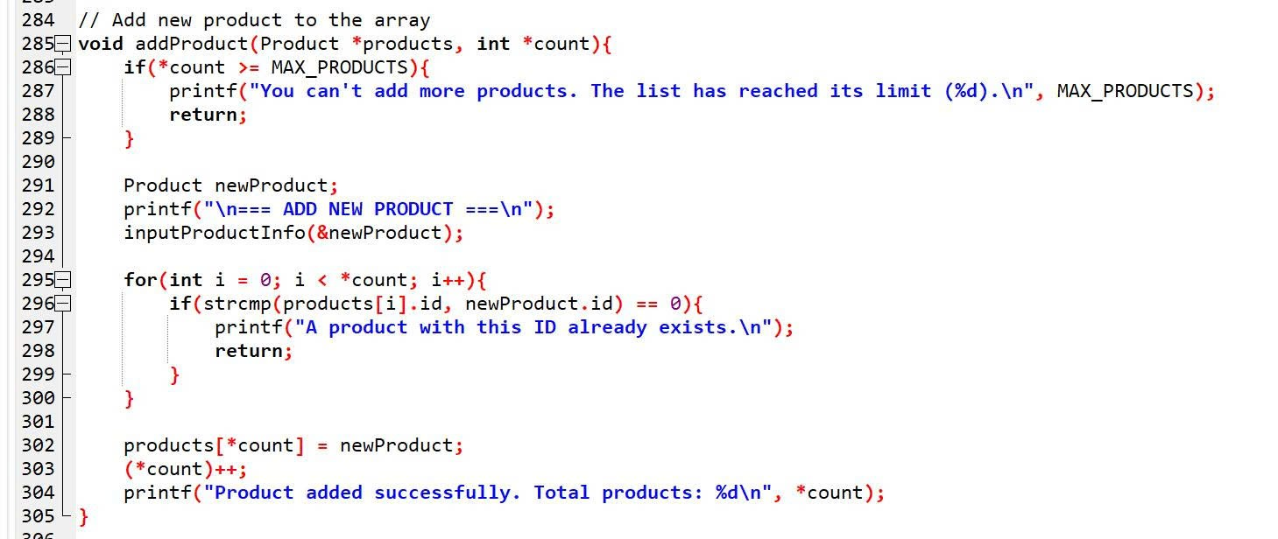

1. **Delete product**

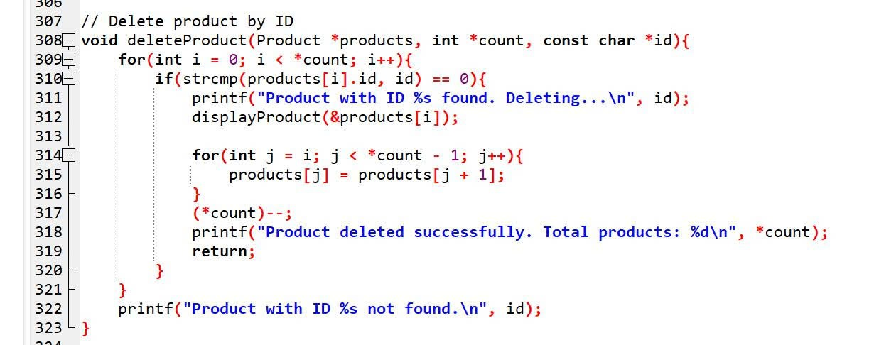

1. **Update product**

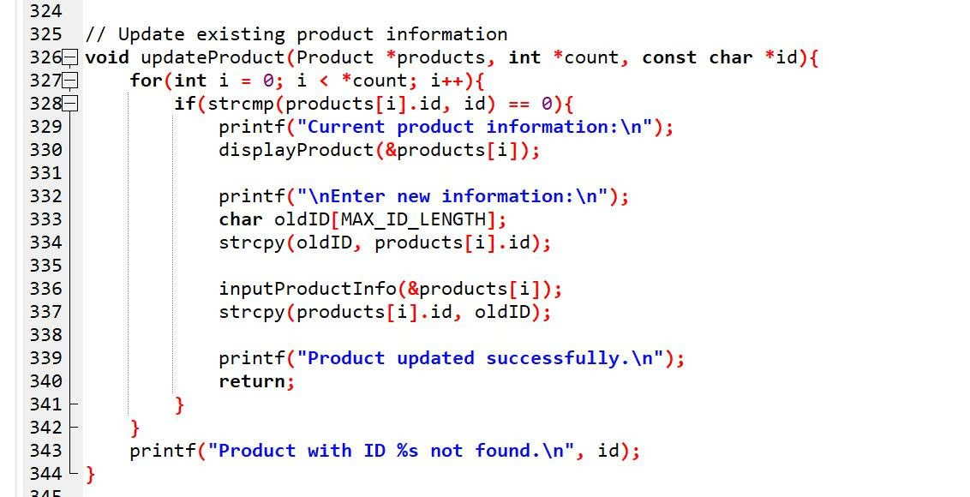

1. **View all product**

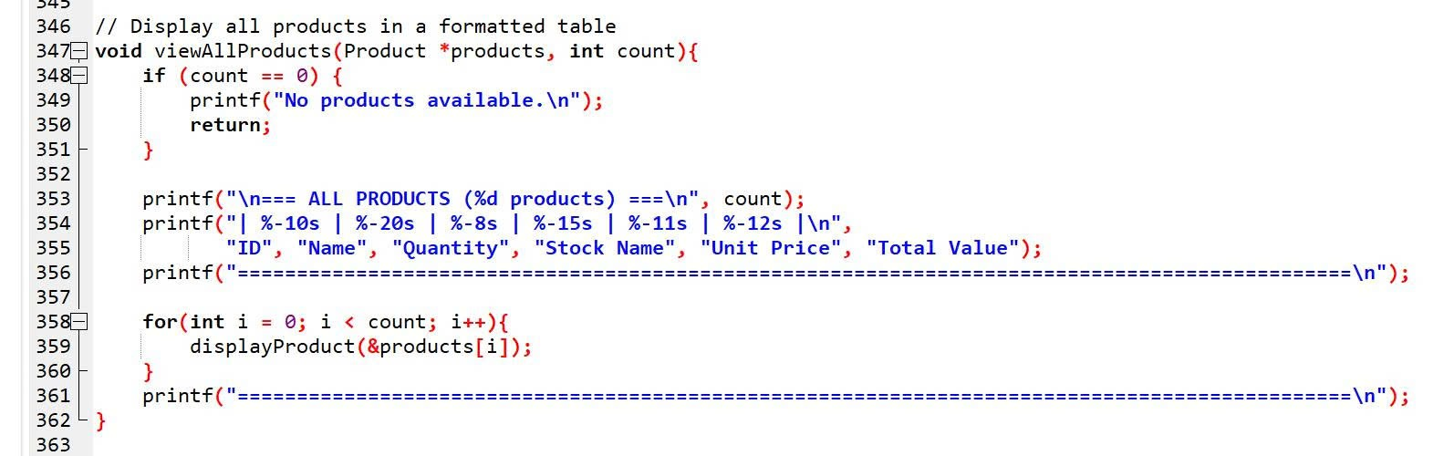

1. **Calculate total Value**

**12.1 Single product**

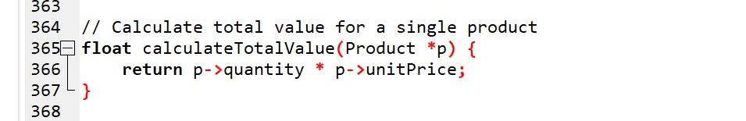

**12.2 All products**

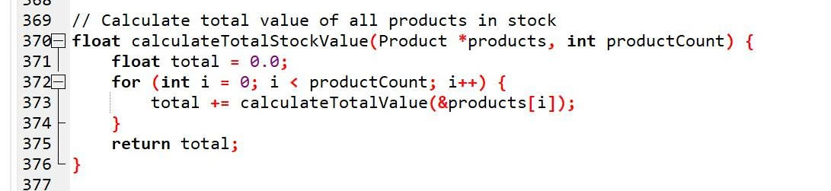

1. **Statistic by stockname**

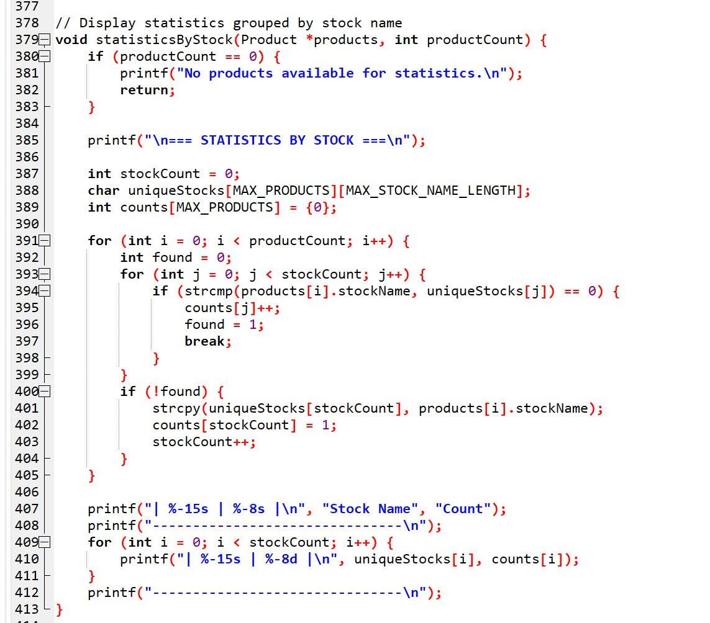

1. **Sort**

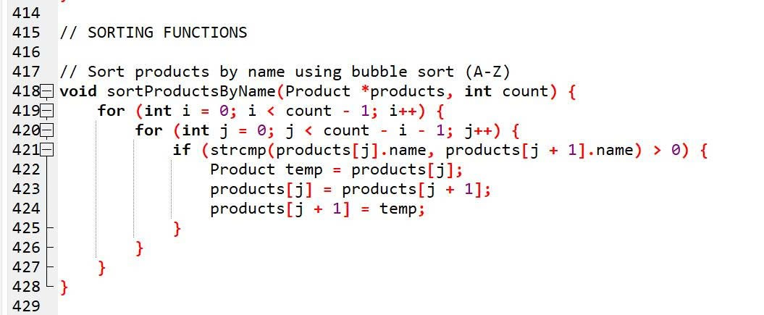

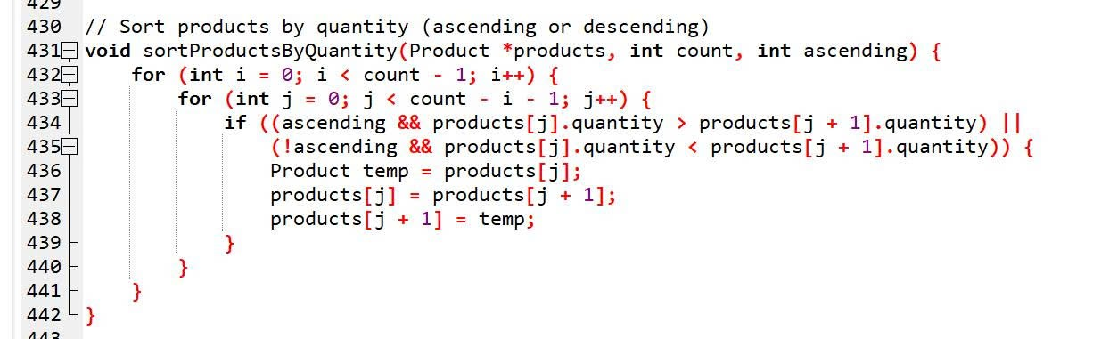

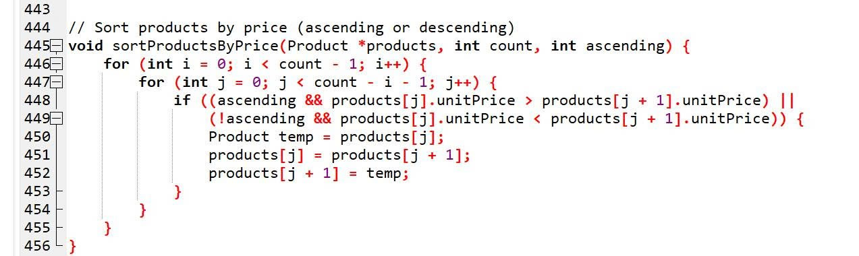

1. **Save and Load**

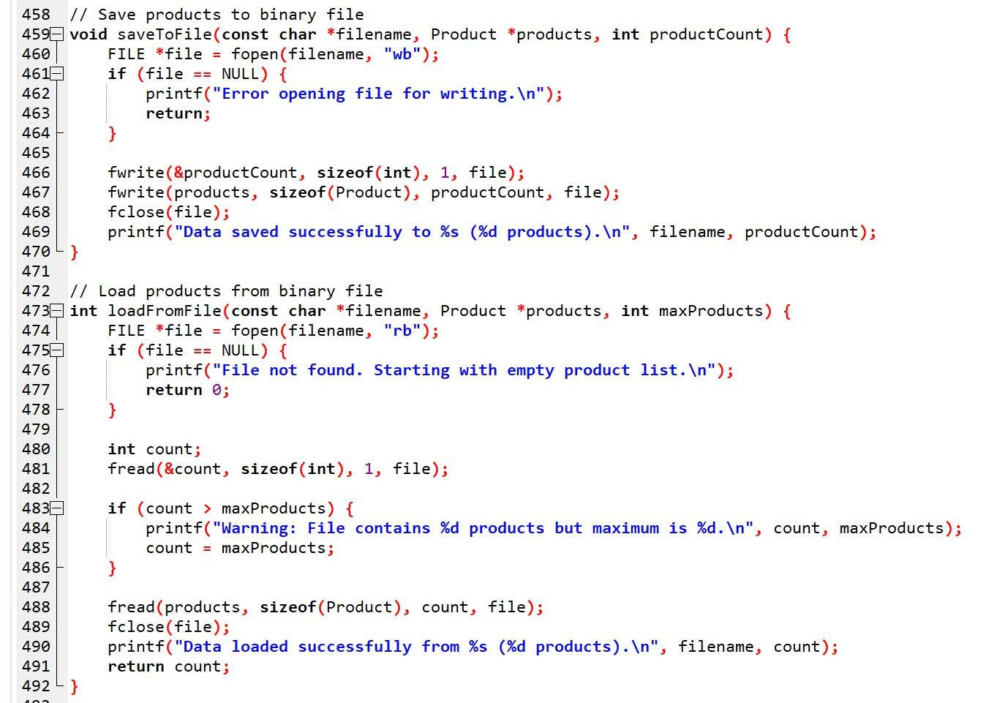

1. **Display menu**

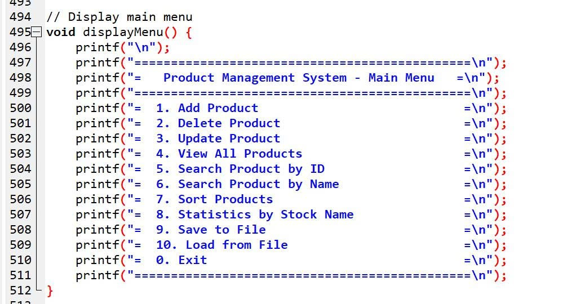

1. **Sort Menu**

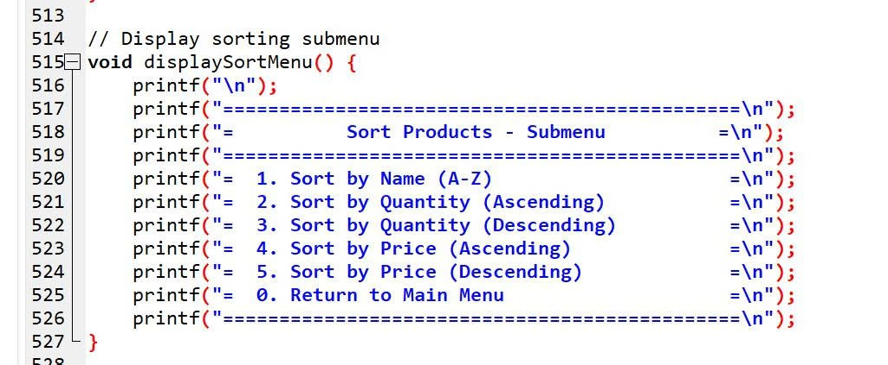

1. **Get User Choice**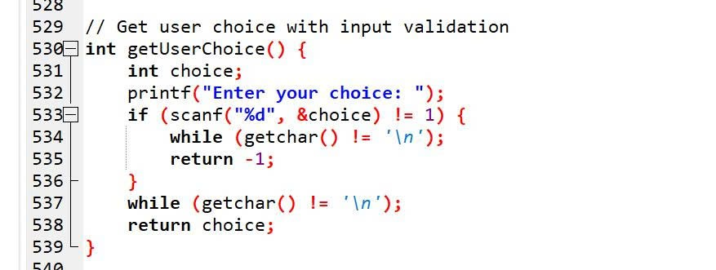
2. **Return Choice**

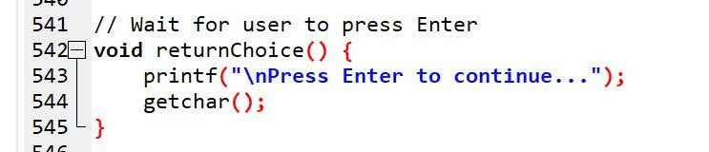

1. **Exit**

